A picture containing clipart

Description generated with very high confidence

Azure 103 Module 4

Hands On - 5

Azure Certification Training

[**support@intellipaat.com**](mailto:support@intellipaat.com)

**+91-7022374614**

**US: 1-800-216-8930(Toll Free)**

**Azure 103 Module 2 , Hands On – 5**

**Create Azure File Share**

**Step 1:** Open Resource Group page

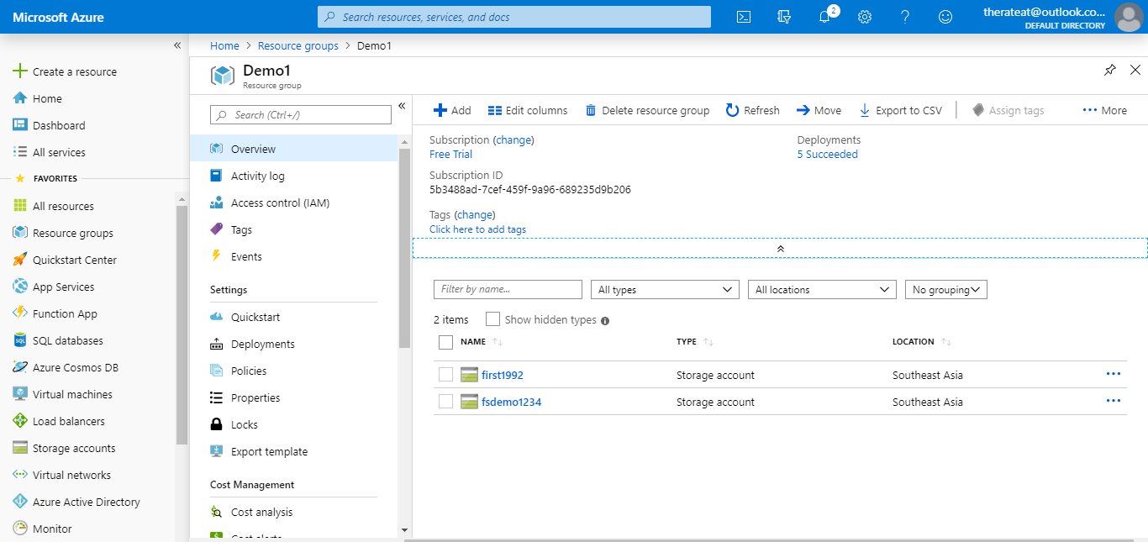

**Step 2:** Click on add.



**Click here**

**Step 3:** Search for storage account and click on it.

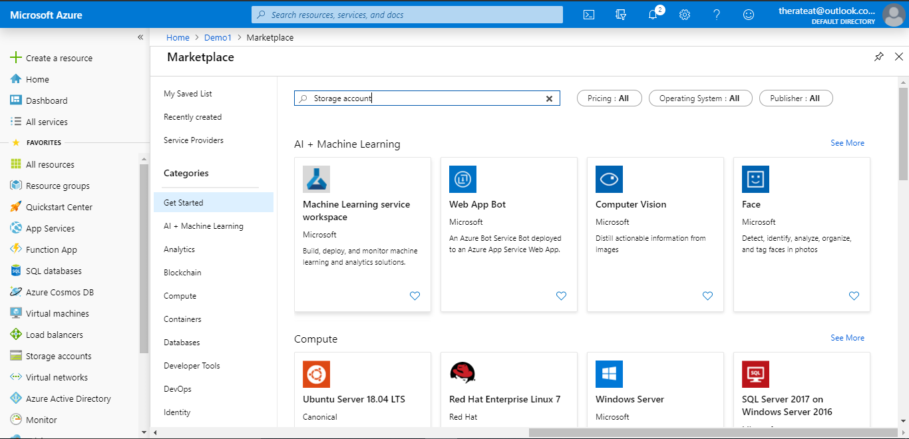

**Step 4:** Click on create.

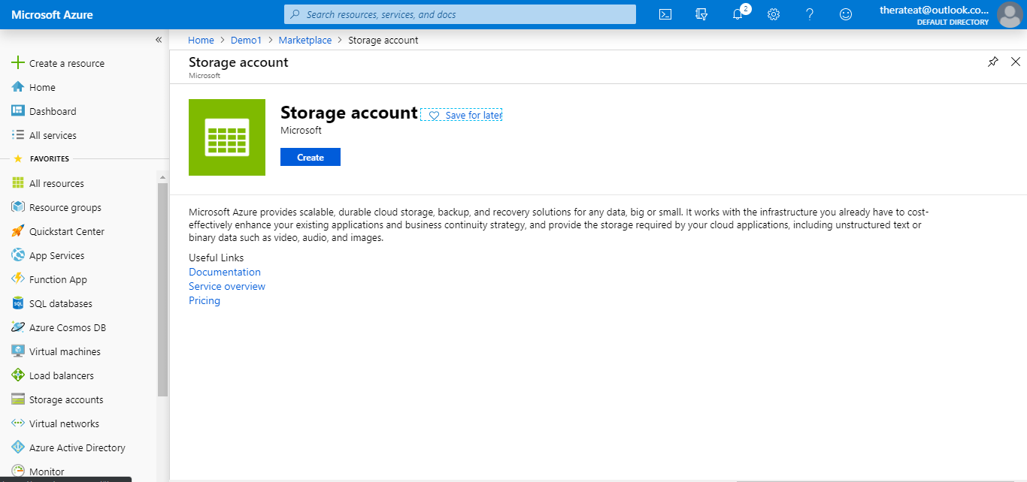

**Click here**

**Step 5:** Fill the details.

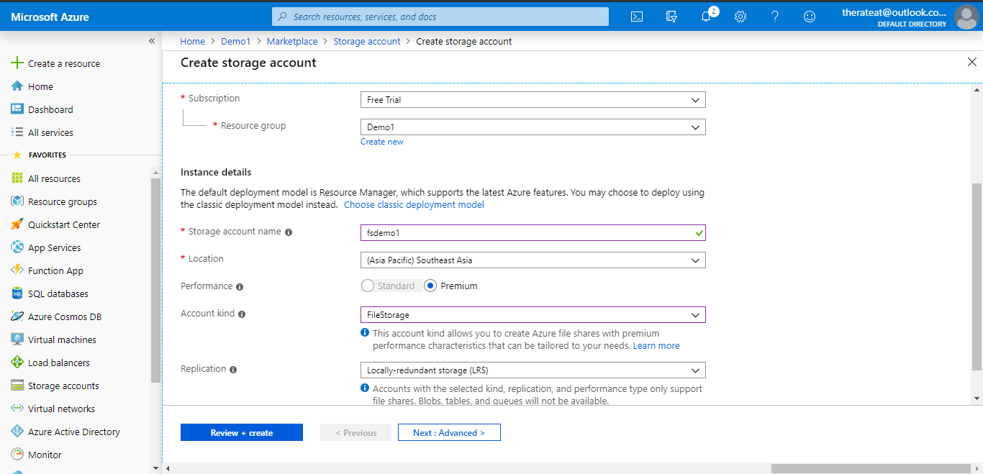

**Step 6:** Click on Review + Create

**Step 6:** Click on ‘Review + Create’.



**Click here**

**Step 7:** Click on create after it passes validation.

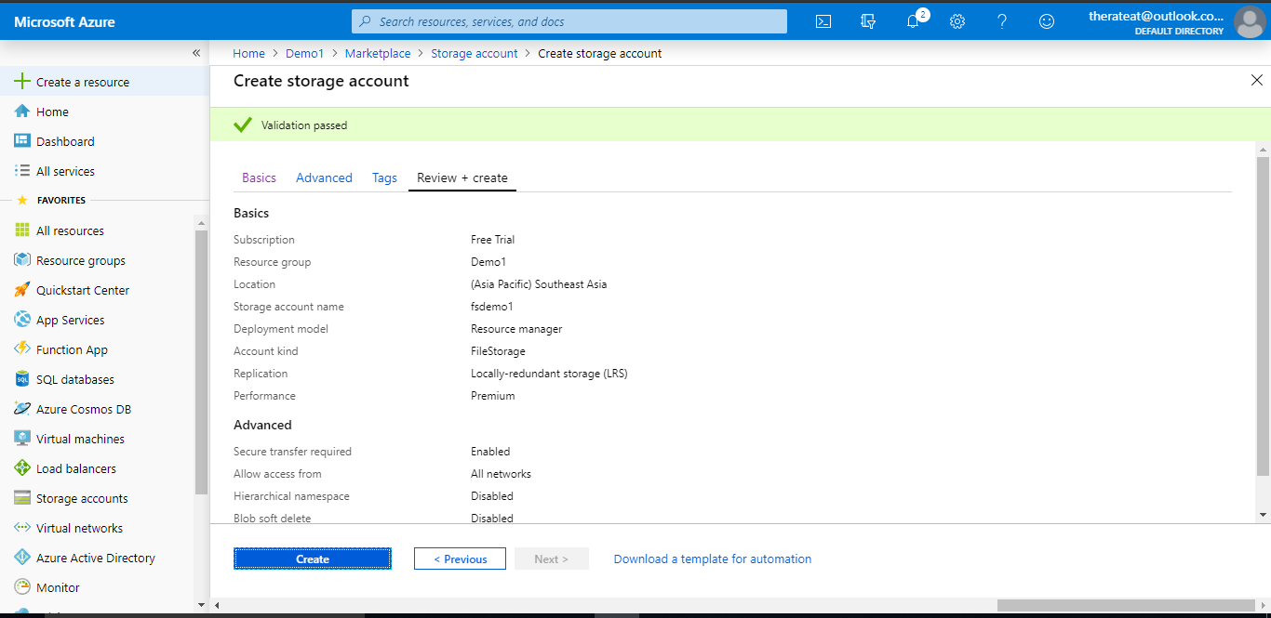

**Click here**

**Step 8:** Click on goto resourse.

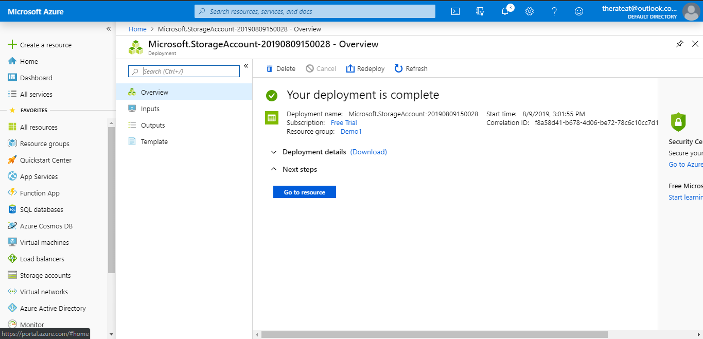

**Click here**

**Step 9:** In the services section click on files.

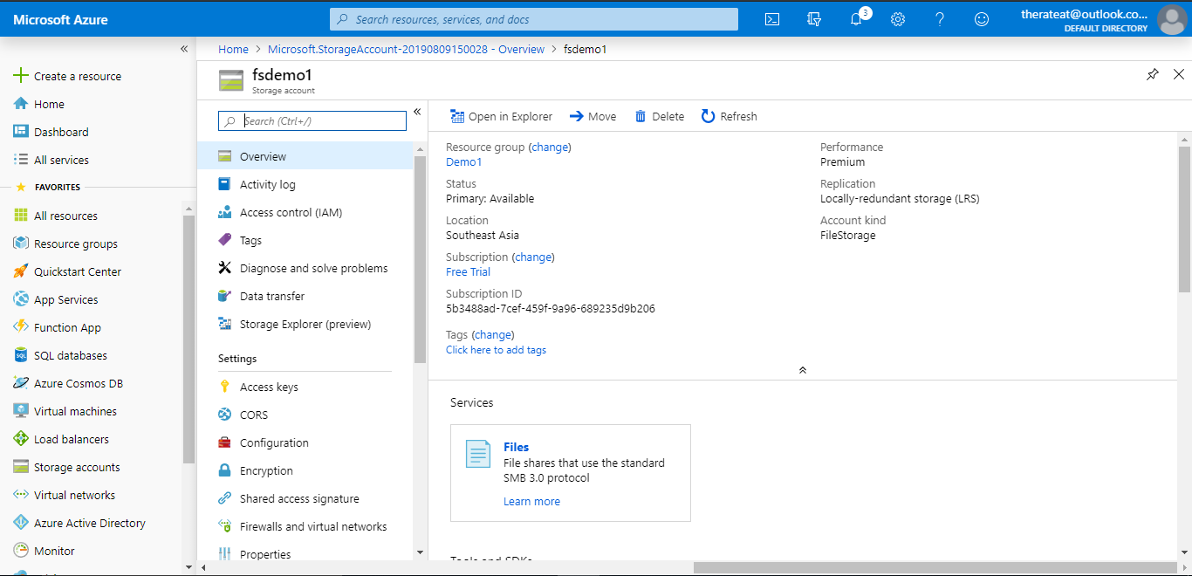

**Click here**

**Step 10:** Step 5: Click on ‘+ File Share‘ button.

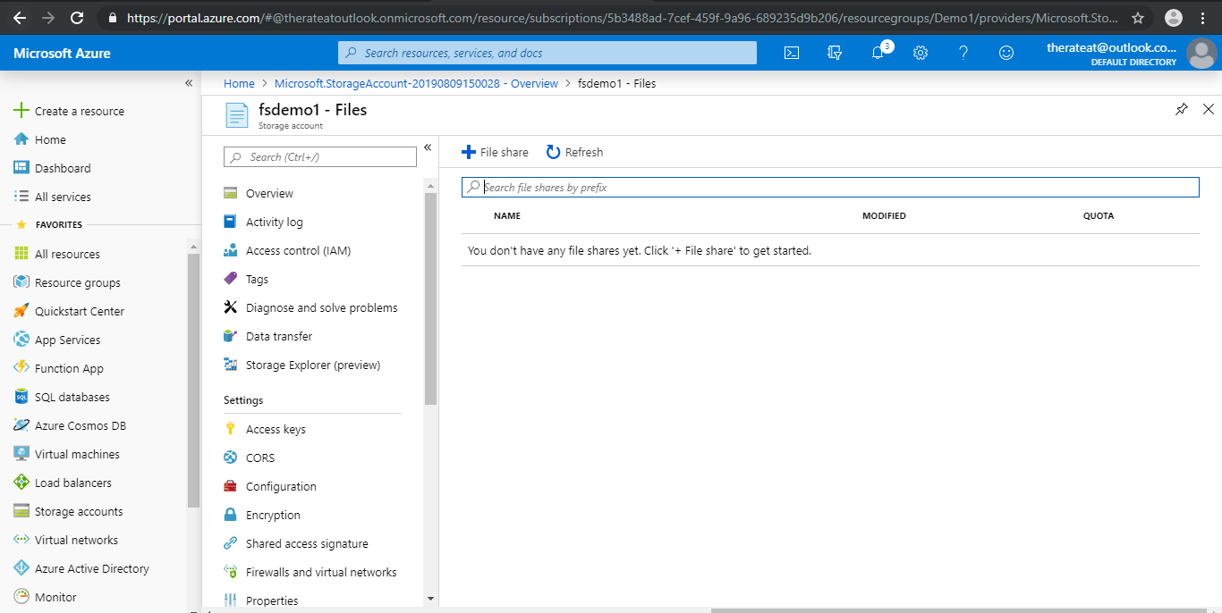

**Click here**

**Step 11:** Give fileshare a name like 'demo'. Quota size of 100 GB.

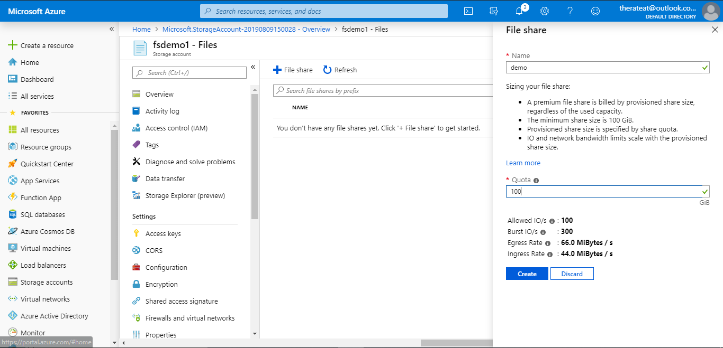

**Step 12:** Click on create.



**Click here**

**Step 13:** Create a key pair on the client machine.

